Table of Contents
The Transformation of Automation and Intelligence 2
Deep Learning & Neural Networks 2
Natural Language Processing (NLP) 2
Computer Vision & Image Recognition 2
Hybrid & Multi-Cloud Infrastructure 3
Kubernetes & Containerization 3
Serverless Computing 3
Cloud Cost Optimization (FinOps) 3
Modern Data Mesh & Governance 4
Real-Time Data Streaming 4
Data Quality & Lineage Tracking 4
Business Intelligence Dashboards 4
Zero Trust Security Architecture 5
Multi-Factor Authentication (MFA) 5
Endpoint Detection & Response (EDR) 5
Data Encryption Standards 5

Artificial Intelligence & Machine Learning

The Transformation of Automation and Intelligence
- Description: Organizations are moving beyond simple repetitive task execution to goal-based intelligent automation, which uses predictive analytics, large language models, and AI agents to autonomously plan, decide, and act

Deep Learning & Neural Networks
- Replicating complex human brain processing layers to recognize abstract patterns and automate high-level decision making.
Natural Language Processing (NLP)
- Empowering modern computer software to parse, comprehend, interpret, and accurately manipulate conversational human text and spoken language.
Computer Vision & Image Recognition
- Granting digital systems the ability to extract highly accurate contextual data out of digital images, videos, and visual environments


Cloud Computing

Hybrid & Multi-Cloud Infrastructure
- Description: The strategic distribution of applications across multiple public cloud vendors and private on-premise servers to optimize costs, minimize lock-in, and guarantee maximum uptime.

Kubernetes & Containerization
- Packaging software applications into standard units (containers) ensuring they run identically on any cloud environment or distributed microservices architecture.

Serverless Computing
- Executing code application blocks dynamically without managing underlying physical infrastructure, utilizing scale-to-zero models where companies pay only for exact execution times.

Cloud Cost Optimization (FinOps)
- Applying structured financial disciplines to cloud usage, utilizing tagging, automated resource scheduling, and asset resizing to eliminate wasteful spending on idle infrastructure.



Data & Analytics

Modern Data Mesh & Governance
- Description: Decentralizing data ownership across business domains to treat data as a high-quality internal product, ensuring regulatory compliance and high-speed analytical power.

Real-Time Data Streaming
- Processing millions of data events per second using streaming platforms like Apache Kafka, enabling instant business decision-making and rapid operational reaction.

Data Quality & Lineage Tracking
- Mapping the precise visual journey of data from its raw source to its final dashboard visualization, guaranteeing data accuracy and strict audit compliance.

Business Intelligence Dashboards
- Translating massive, complex data structures into intuitive, interactive visual interfaces (like PowerBI) to empower non-technical executives with actionable metrics.

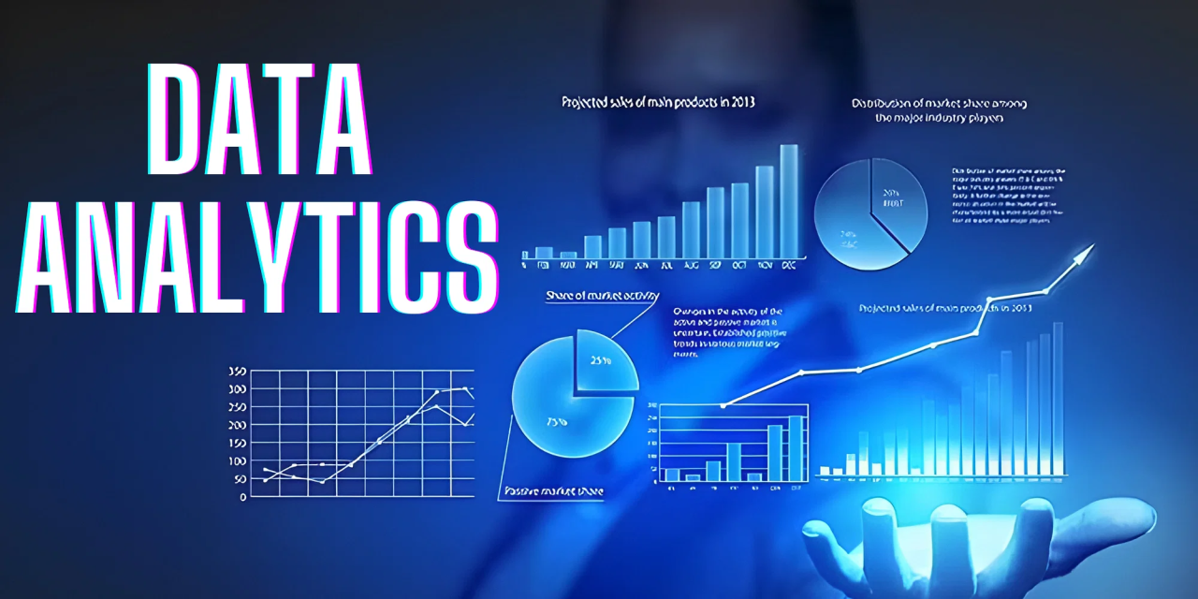

Cybersecurity

Zero Trust Security Architecture
- Description: Shifting security paradigms away from perimeter-based firewalls to a strict security model where every user and device must be continuously verified, regardless of network location.

Multi-Factor Authentication (MFA)
- Requiring distinct pieces of evidence (passwords, biometrics, hardware tokens) to grant access, mitigating risks from compromised corporate credentials.

Endpoint Detection & Response (EDR)
- Deploying continuous monitoring tools across user endpoints (laptops, mobiles) to identify, contain, and isolate advanced ransomware or phishing incursions.

Data Encryption Standards
- Securing sensitive digital assets using state-of-the-art cryptographic protocols both while stored on disks (at rest) and moving across public/private networks (in transit).


